**Game Documentation:**

Title

Title of Game: J’s Bounty

Name: Jack Furmanek

Date: 12/29/2016

Summary and Target Audience

Goal of the Game: The goal is to reach the End Space and claim J’s Bounty.

Context: 10 Years ago, there was a mass murderer and con artist known as J. His reign of terror instituted across several solar systems gave him the nickname: King of Terror. He was eventually overthrown and imprisoned for life for his crimes. But now, he has recently escaped his imprisonment and gone into hiding. At the same time, an unknown dealer has offered a massive bounty for his capture, leading the best bounty hunters in the galaxy to look for him. His location is known due to a tracking implant in his chest. However, J has placed several obstacles to prevent anyone from reaching him. Now it is up to you to reach his location, capture him, and become the richest bounty hunter in the galaxy with the help of J’s Bounty.

Target Audience: Ages 13 and up. The game contains a lot of complex rules and actions that may be too complicated for those under 13. The game will also take about 1-1.5 hours to finish, which is unsuitable for younger players without patience.

Theme

Description of Bounty: A dealer has put up a major bounty, entitled J’s Bounty, and now every Bounty hunter in the galaxy wants to get it. To obtain the bounty, they must reach J at the End Space. Whoever obtains this will become the richest bounty hunter in the galaxy.

Theme overview: Bounty has influenced the backstory of the game, as well as the motivation to play the game.

Backstory: Ten years ago, there was a mass murderer and con artist known as J. His reign of terror instituted across several solar systems gave him the nickname: King of Terror. He was eventually overthrown and imprisoned for life for his crimes. But now, he has recently escaped his imprisonment and gone into hiding. At the same time, an unknown dealer has offered a massive bounty for his capture, leading the best bounty hunters in the galaxy to look for him. His location is known due to a tracking implant in his chest. However, J has placed several obstacles to prevent anyone from reaching him. Now it is up to you to reach his location, capture him, and become the richest bounty hunter in the galaxy with the help of J’s Bounty.

Board

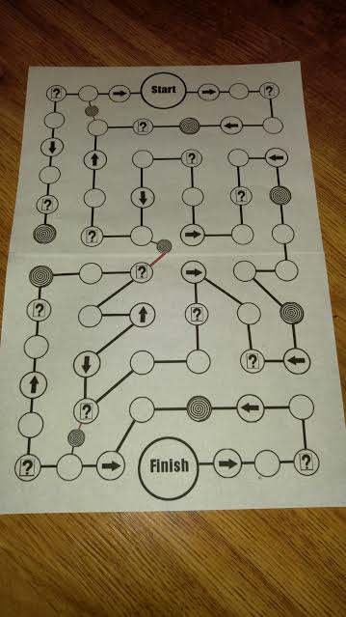

Game Board Description: The Player moves around the board by moving the game pawns to the spaces by following the lines.

Features: Players must roll the dice at the start of each turn to move forward that many spaces. If they land on a movement or card space, they must follow that space’s rules. They continue until they land on a blank space, or fulfill an alternative turn-end condition.

* Movement- the player rolls the dice and moves that many spaces in the direction the arrow is pointing
* Card- the player picks up a card and move the same number of spaces as the number on the card. Also, the direction you move is determined by the color: Red- Backwards, Black- Forwards. If a Joker is drawn, the turn automatically ends.

If a player lands on a spiral space, they roll the dice and move to the appropriate portal depending on the roll. Portal 1 (Closest to Start)-1 or 2, Portal 2 (Middle)- 3 or 4, Portal 3 (Closest to Finish)- 5 or 6. From that portal space, they pick up the top card on the deck and travel on the path that is the same color as the card to the respected space (if it is a joker, the card goes on the discard pile and a new card is drawn).

Game Pawns

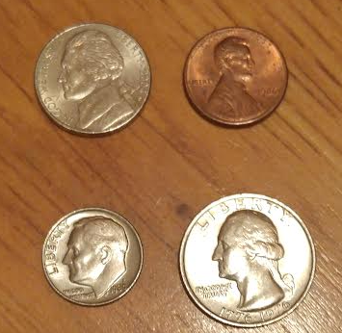

Game Pawns: Can be any four different pieces. For convenience sake, I chose a Penny, Nickel, Dime, and Quarter.

Usage: The player uses their respective Pawn to move around the board and eventually reach the finish to acquire J’s Bounty.

Representation: The Pawns represent the bounty hunters who are trying to obtain J’s Bounty.

Other Game Materials

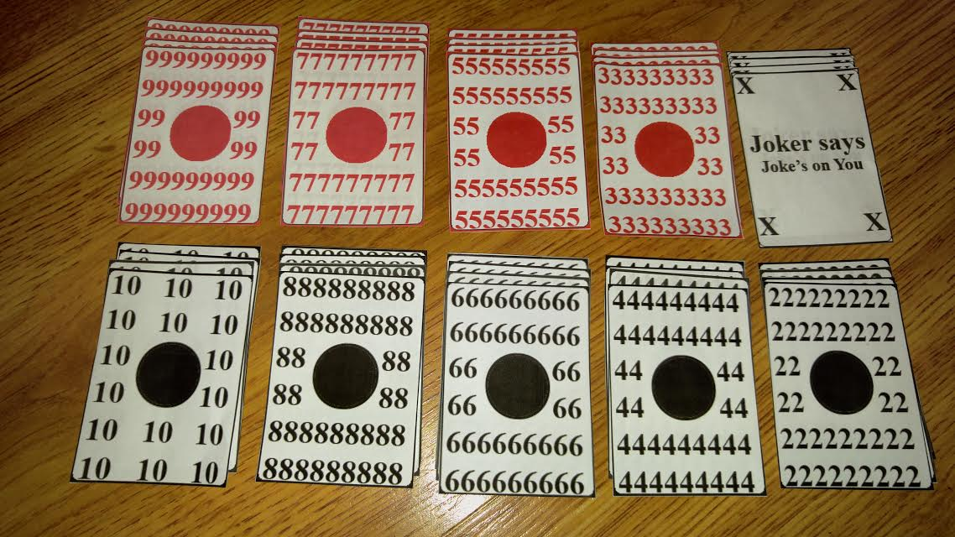

Cards

Usage: The Cards are used at various Card spaces across the board indicated by spaces with a rectangle and a small question mark. If a player lands on the space, they flip over the top card on the deck and follow its rules. The player moves the same number of spaces as the number on the card. Also, the direction you move is determined by the color: Red- Backwards, Black- Forwards. If a Joker is drawn, the turn automatically ends.

If a player lands on a spiral space, they roll the dice and move to the appropriate portal depending on the roll. Portal 1 (Closest to Start)-1 or 2, Portal 2 (Middle)- 3 or 4, Portal 3 (Closest to Finish)- 5 or 6. From that portal space, they pick up the top card on the deck and travel on the path that is the same color as the card to the respected space (if it is a joker, the card goes on the discard pile and a new card is drawn).

Game Rules

A complete game rulebook can be accessed by the [following link](https://drive.google.com/open?id=1IawL_20geI9PMj7TCDxK73ziYjTc0PUAmeWd12Drw2k).

Game Sequence Demo

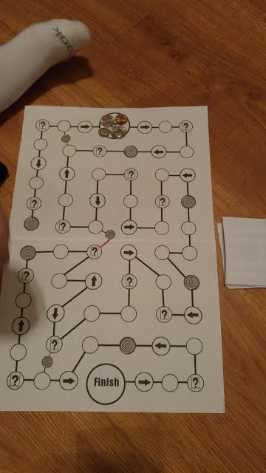

The Game board set up and ready to play

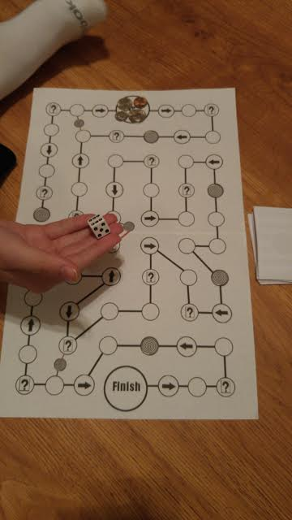

Player 1 about to roll off to start the game

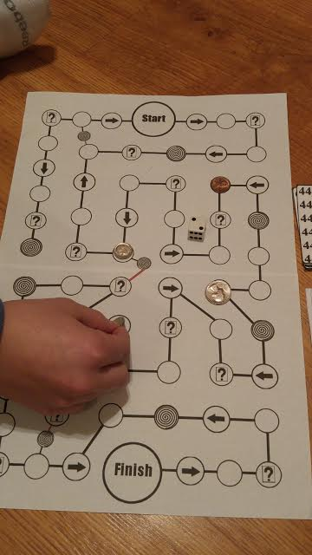

Player 1 moving their game pawn after rolling

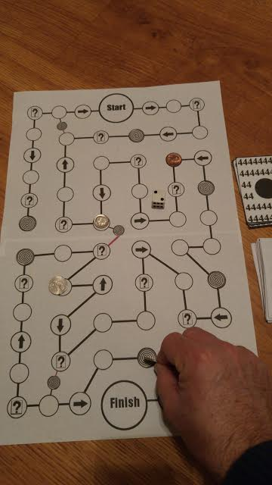

Player 2 moving their pawn after rolling

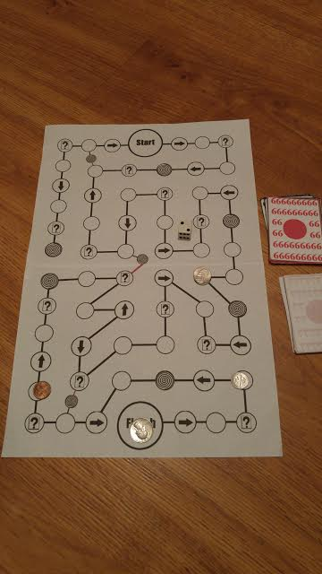

Player 2 has reached the Finish and won the game.

Game Reflection

Best: The aspects are the combination of dice and cards, as well as the complexity of the game are its best aspects

Need Improvement: The cards need more variety, and the board needs to have a few more spaces. There also should be an aspect at the end to prevent a lucky player from winning instantly. Some games also took a long time to finish. I need to find a way to speed up gameplay.

Learned: How hard it is to design games, how tricky it is to make the rules of the game, and also how to make a functioning game fun for everyone.